Lebanese American University

MECHANICAL ENGINEERING DEPARTMENT



**Self-Parking Car**

Jan Carlos Gebrel

Michael Feghali

Mohamad Mrad

*System Design 1, MCE 410*

Monday, December 19, 2022

Table of Contents

Introduction 3

Materials 4

Project 5

Schematics 5

Motors: 5

Ultrasonic sensor: 5

LED: 6

Assembly 7

Individual parts: 7

Coding: 8

Full Design: 9

Results 10

Possible Improvements: 10

# Introduction

One of the biggest struggles for drivers is parking. Even the most experienced drivers often have difficulties while parking in tight spots especially with other vehicles being at near proximity. Nowadays, automatic self-parking systems are getting ever-more-prevalent in order to help alleviate this issue with the use of technology.

Knowing all of this, our project is the design, creation and implementation of a self-parking vehicle, a small rover in this case, which will find a parking space and park all by itself.

Currently, many solutions to this problem exist in the market. Many big-name companies such as Tesla, BMW, Mercedes and others have developed cars with self-parking systems to facilitate parking for the user. This inspired us to create this project.

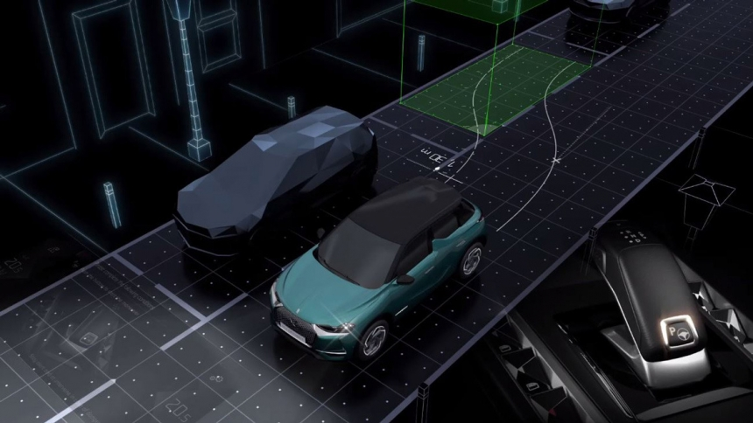

# Materials

For this project we used the following materials:

* Rover
* Raspberry Pi
* L298N
* Breadboard
* Ultrasonic HC-SR04
* LEDs
* Resistors
* Wires
* Power supply
* Solder and solder wire

# Project

## Schematics

### Motors:

For this project we only used two motors, which are enough to control the car, to go forward, backwards, left, and right. For this, we used the L298N motor driver using the following schematic:

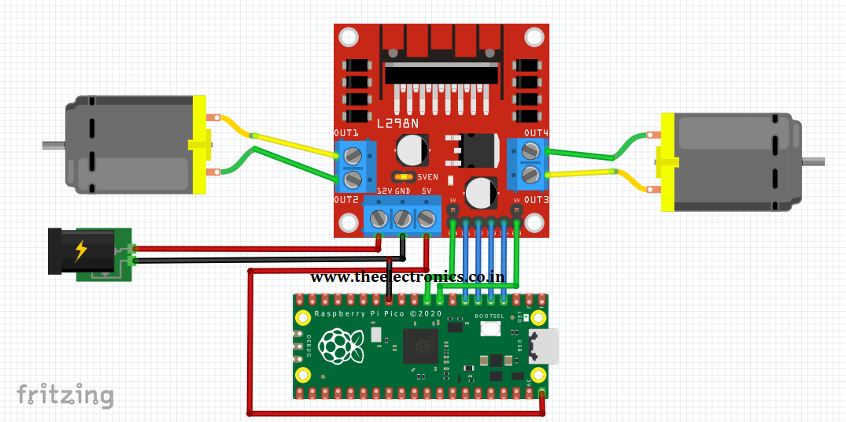

Where the motors were connected to GPIOs (General Purpose Input Output), which were later used in the coding part, also an enable and a power supply (external and raspberry pi 5V) was connected.

### Ultrasonic sensor:

For the Ultrasonic sensor we followed the following schematic:

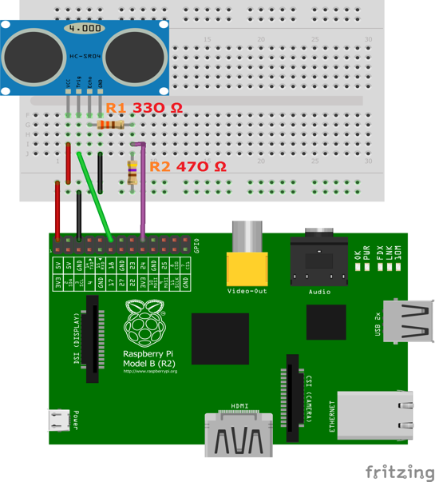

Where the ultrasonic sensor was placed in a board and connected to the raspberry pi by those connections taking in mind that two resistors were used: one of 330 ohms and 470 ohms, but since we could not find a 470 ohms resistor, so we used two 1k ohms resistor in parallel which would give an equivalent of 500 ohms which is sufficient.

### LED:

This is the simplest one of the project since it only required a resistor, wire and a LED which looks like:

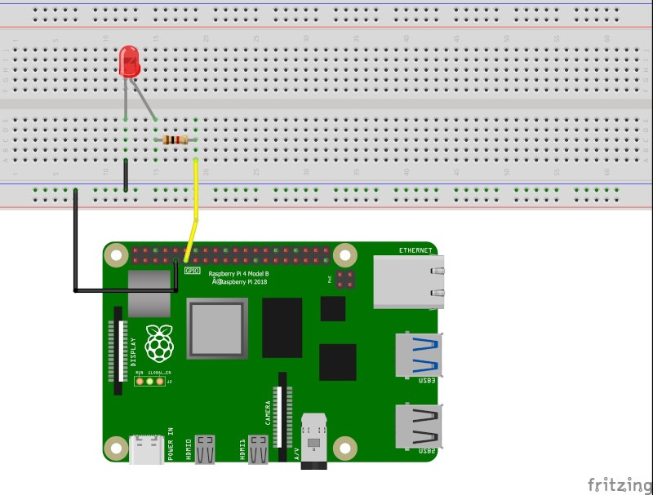

Where a 330 ohms resistor was used.

## Assembly

### Individual parts:

Even though there are tutorials that were used as references for the different components of the model, many of them do not provide in-depth explanations or which led to many trials and errors and troubleshooting.

Rover: This is the chassis of the car, and even though it looks straight forward, it did not come with instructions which led to 1 hour of assembly.

L298N motor driver: Several different configurations (wiring and code) were tested until we reached the above schematics. We also soldered wires to the DC motors since they would not stay in place leading to a sudden stop of the motor. In addition, some of the DC motors were rotating at different speeds when supplied from the same power supply which caused the rover to rotate unexpectedly.

Ultrasonic Sensor: For this project, we used the HC-SR04 which determines whether there is an available parking space by measuring the distance (depth) in centimeters.

LED: The addition of the LED is a simple additional touch where the LED will turn on every time an obstacle is close to the car (the parking spot is occupied) and turn off if there is a clear space.

### Coding:

The individual parts of code for each component were joined together for the final assembly in order to have the fully functional design.

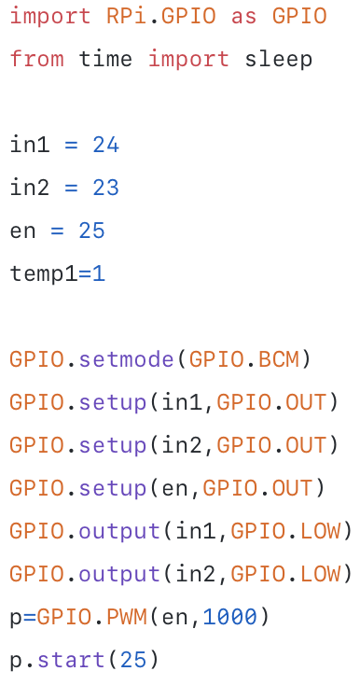

Motor driver: We initialized the GPIO, then the GPIO used

and set them to LOW (not running). And then an infinite Loop

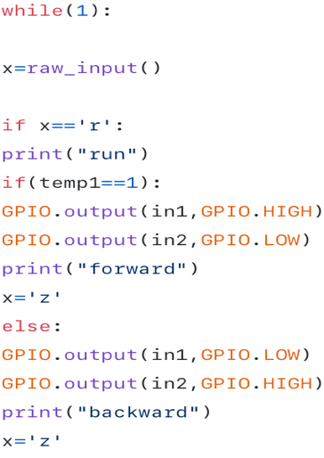where if you input ‘r’ the motors would start spinning forward,

‘b’ backwards, and ‘s’ to stop the car.

Ultrasonic Sensor + LED: Both are placed on the same code since the LED is dependent on the ultrasonic sensor reading. In our case, if there is an object closer than 12cm to the vehicle the ultrasonic sensor will detect it and turn on the LED and turn off if it is clear. The ultrasonic sensor also gives us an accurate distance every second which we will use to our advantage to know if the distance is enough to park the car. To calculate the time, we had to subtract the time when an object was detected from the time when it was clear.

### Full Design:

Having already assembled the individual parts, they were then joined together on a single breadboard with connections from the raspberry pi and power supply.

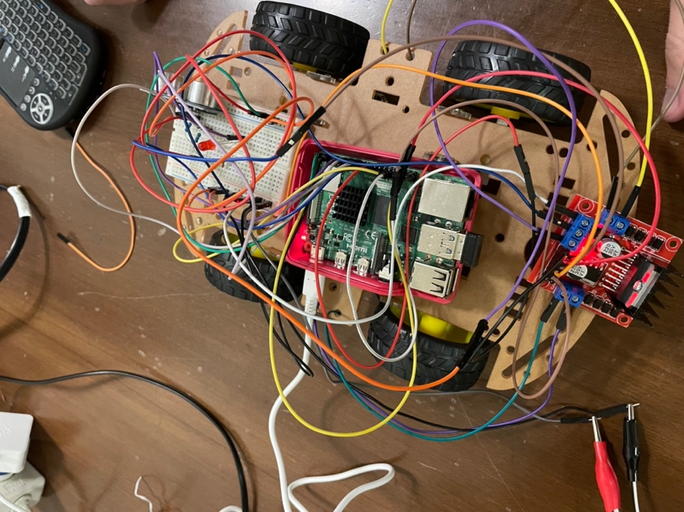

However, as is clearly shown in the picture, the large quantity of long made it slightly difficult to test our design as the wires tended to get caught behind the wheels and cause issues.

Nevertheless, we were able to assemble the rover and get the model to work properly.

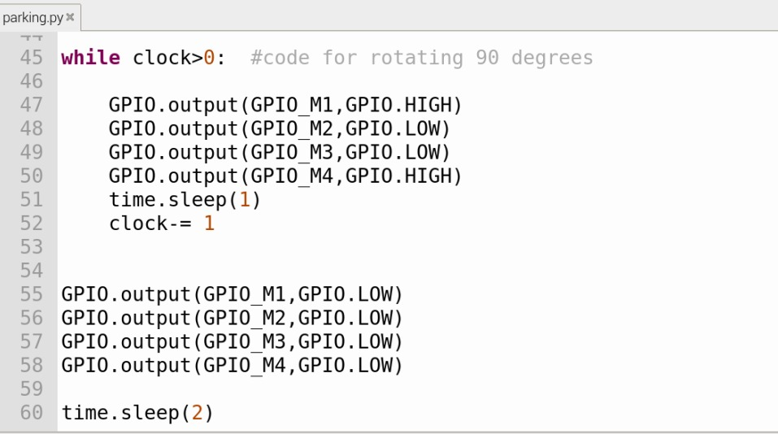For the coding part, simply joining all the individual codes together was not enough since the purpose of the project is for the car to self-park, not only move and measure the distance. When combining the already prepared codes, we inserted the ultrasonic sensor code inside the forward part of the motor driver code, which 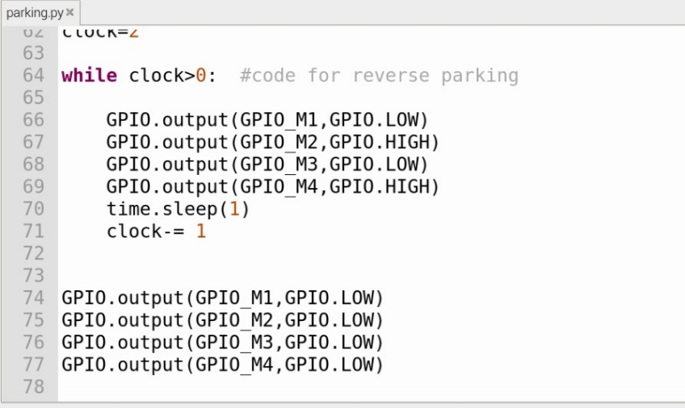means, we start the self-parking mechanism when forward motion is selected. We also had to add the parking code which is activated when an empty spot is detected. This consists of performing a 90-degree rotation by spinning both motors(wheels) in opposite directions and the moving the rover backwards.

## Results

The rover was able to detect and park in an empty parking spot successfully as expected. This will be displayed in our video and live demos. It should be noted that these results may vary based on the surface which the rover is traversing on. This is due to the difference in grip and friction between the wheels and other surfaces. In addition, in order to increase the torque generated and allow the wheels to spin properly, we had to increase the weight of the rover by adding objects on top of it.

## Possible Improvements:

Furthermore, the ultrasonic sensor was placed facing the left side of the rover which means that it can only detect parking spaces to the left side of the road. Therefore, the design can be improved by introducing a second sensor facing the right side of the road. In addition, we used a large power supply in order to ensure the motors get enough voltage and current. In order to have more organized wiring, we can use a battery pack as the main power supply. We attempted to use batteries while working on the project, however, they did not provide enough voltage.